# Unit Test #3

1. Write a console application that:
2. prompts the user for a string
3. prints how many of each letter of the alphabet are in the string (case-insensitive, ie. A=a)
4. prints the string in reverse order (eg. "great programmer" should output "remmargorp taerg")
5. tests if the string is a palindrome (allowing for punctuation, spaces and different capitalization) For example,  "Madam, I'm Adam" is a palindrome.

I must say that the connections between these questions are so beautiful!!

1. Implement the Adjacent Matrix and Adjacent List for the following digraph

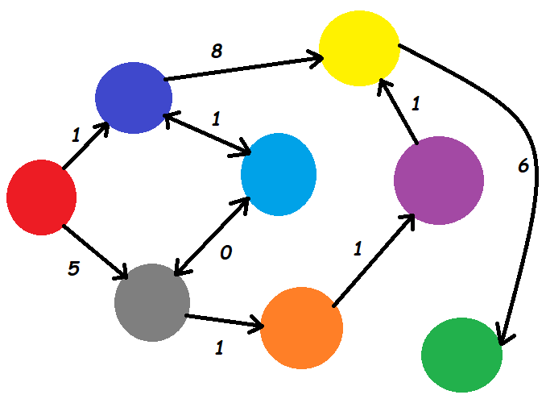



1. Using the in-class example from Week #11, implement a Depth First Search of this digraph starting from red and output the colors.
2. Using the in-class example from Week #12, implement Dijkstra's shortest path algorithm to output the shortest path of colors from red to green.
3. Using the in-class examples from Week #9, implement the digraph as a linked list.
4. Using the binary tree app from Week #10, insert the following numbers into a binary tree in the following order: 1, 5, 15, 20, 21, 22, 23, 24, 25, 30, 35, 37, 40, 55, 60

Traverse the tree in ascending order and load the numbers into a List<int>

Read the numbers out of the List<int> and insert them into a new tree such that the tree will be balanced.

1. Define a Wizard class that contains the following fields:
   * string name
   * int age

Declare a List<Wizard>. Fill the list with 10 Wizard objects with different names and ages. Write the code to use List.Sort() to sort the list based on their age. (Refer to Week #12 in class code).

+5 points if you also implement it as a delegate or lambda expression!

1. Modify the TicTacToe game from Week #12 to implement this Magic Square Game. The goal is to capture 4 spaces that add to 34. Note that there are 86 different solutions, 34 are outlined on the right side of the following image. This magic square first appeared in an engraving by Albrecht Durer in 1514: <https://en.wikipedia.org/wiki/Melencolia_I>

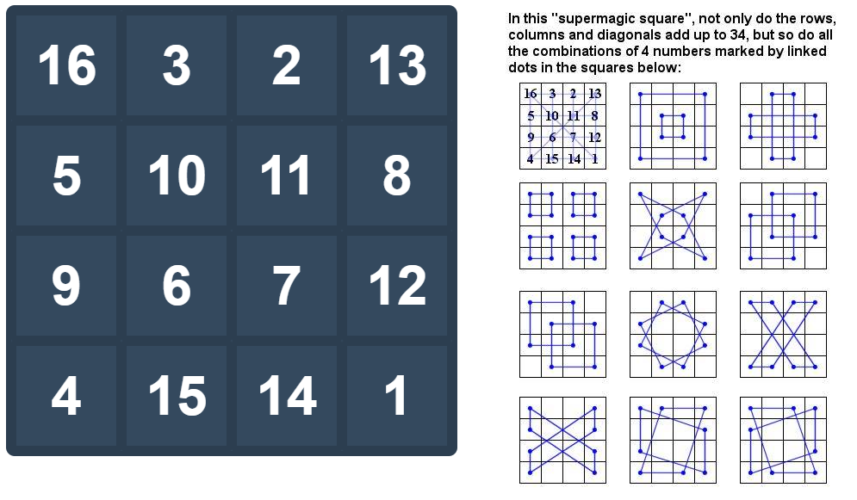

## Submission

Upload the GitHub URL's for all questions to the corresponding myCourses dropbox.